**MINISTRY OF EDUCATION AND TRAINING**

**FPT UNIVERSITY**

Capstone Project Document

**Laptop Reviews**

|  |  |
| --- | --- |
| **Group 1** | |
| **Group member** | Vo Thi Minh Chau – Team Leader – SE60931  Nguyen Van Hon – Team Member - 60390  Dinh Huu Toan – Team Member - SE60871  Nguyen Manh Khuong – Team Member - 60455 |
| **Supervisor** | Mr. Kieu Trong Khanh |
| **Ext. Supervisor** | N/A |
| **Capstone Project code** | LRA |

-Ho Chi Minh City, ***05/2015***-

*This page is intentionally left blank*

***ACKNOWLEDGEMENTS***

We wish to thank various people for their contribution to this project: Our teachers for their advice and participation in the final review, our friends for their valuable technical support.

Special thanks should be given to Mr.Kiều Trọng Khánh, our research supervisor for his professional guidance and the useful, constructive recommendations throughout the course of this project.

# Table of Contents

Table of Contents 4

List of Tables 5

List of Figures 6

Definitions, Acronyms, and Abbreviations 7

Report No.4 Software Design Description 8

1. Design Overview 8

2. System Architectural Design 9

3. Component Diagram 10

4. Detailed Description of Components 11

4.1 Class Diagram 11

4.2 Class Diagram Explanation 11

4.3 Sequence Diagram 15

5. User Interface Design 18

6. Database Design 18

6.1 Logical Diagram 18

6.2 Data Dictionary 19

7. Algorithms 21

7.1 Analyze Comment 21

7.2 String Comparison 21

# List of Tables

Table 1: Entity Data Dictionary 18

Table 2: Attribute Data Dictionary 19

# List of Figures

Figure 1: MVC Architecture 9

Figure 2: Component Diagram 10

Figure 3: Class Diagram 11

Figure 4: Force Parse Data Sequence Diagram 15

Figure 5: Import Excel Sequence Diagram 15

Figure 27: Logical Diagram 17

# Definitions, Acronyms, and Abbreviations

|  |  |
| --- | --- |
| LRA | Laptop Review |

# Report No.4 Software Design Description

## Design Overview

* This document describes the technical and user interface design of Laptop Reviews System using web. It includes the architectural design, the detailed design of common functions and business functions and the design of database model.
* The architectural design describes the overall architecture of the system and the architecture of each main component and subsystem.
* The detailed design describes static and dynamic structure for each component and functions. It includes class diagrams, class explanations and sequence diagrams for each use cases.
* The database design describes the relationships between entities and details of each entity.
* Document overview:
* Section 2: gives an overall description of the system architecture design.
* Section 3: gives component diagrams that describe the connection and integration of the system.
* Section 4: gives the detail design description which includes class diagram, class explanation, and sequence diagram to details the application functions.
* Section 5: describe an ERD with logical diagram.

## System Architectural Design

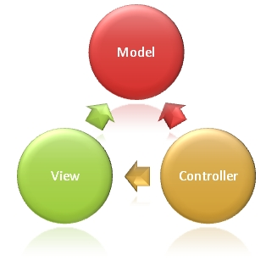

Figure 1: MVC Architecture

**(http://www.w3schools.com/aspnet/mvc_intro.asp)**

**The Model** is the part of the application that handles the logic for the application data.  
Often model objects retrieve data (and store data) from a database.

**The View** is the parts of the application that handles the display of the data.  
Most often the views are created from the model data.

**The Controller** is the part of the application that handles user interaction.  
Typically controllers read data from a view, control user input, and send input data to the model.

## Component Diagram

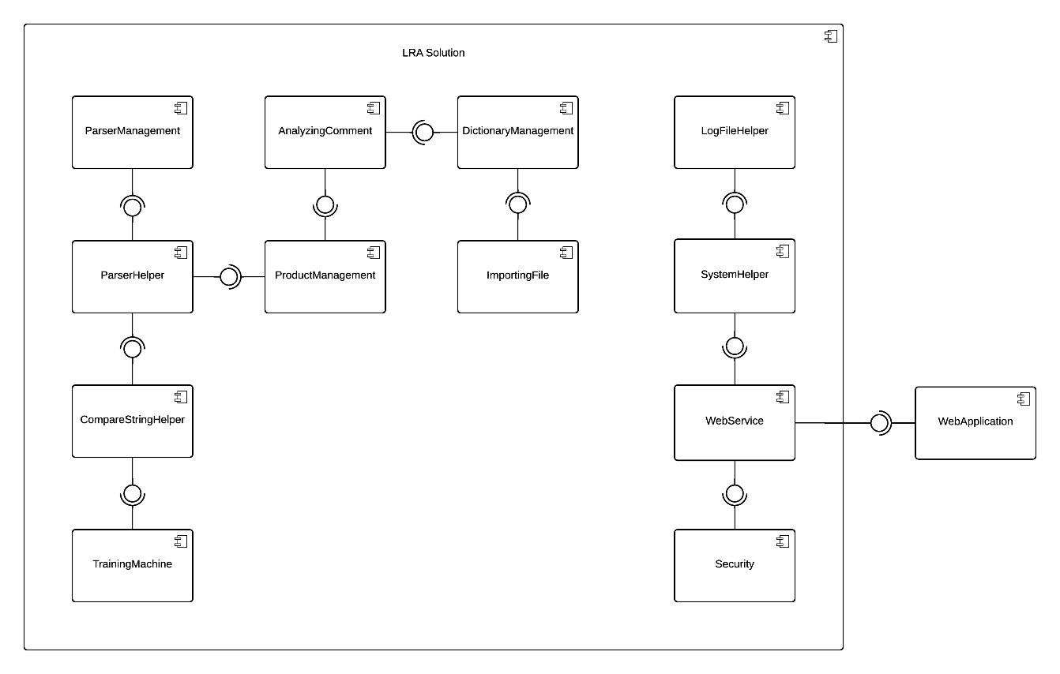

Figure 2: Component Diagram

## Detailed Description of Components

### Class Diagram

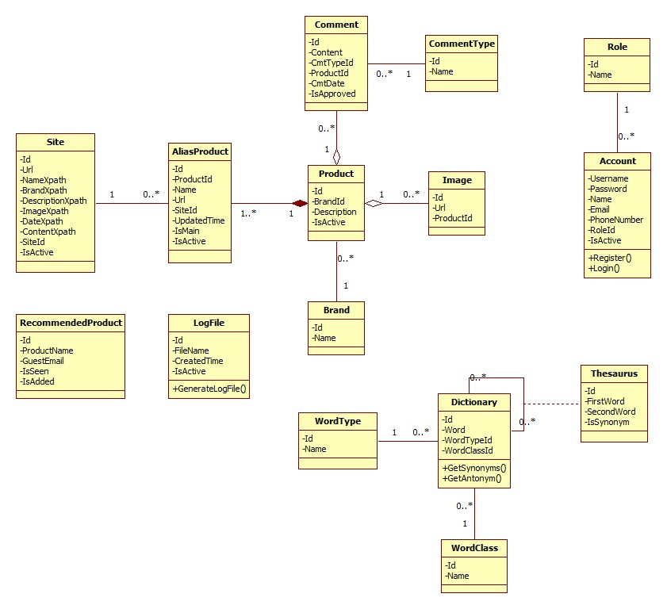

Figure 3: Class Diagram

### Class Diagram Explanation

#### Site

Attribute

|  |  |  |  |
| --- | --- | --- | --- |
| **Attribute** | **Type** | **Visibility** | **Description** |
| Id | Integer | Public | Unique identifier of each site |
| Url | String | Public | Url value |
| NameXpath | String | Public | Xpath value of product name |
| BrandXpath | String | Public | Xpath value of product brand |
| ImageXpath | String | Public | Xpath value of product image |
| DateXpath | String | Public | Xpath value of date value |
| ContentXpath | String | Public | Xpath value of product content |
| SiteId | Integer | Public |  |
| IsActive | Boolean | Public | Value use to enable/disable the site |

#### AliasProduct

Attribute

|  |  |  |  |
| --- | --- | --- | --- |
| **Attribute** | **Type** | **Visibility** | **Description** |
|  |  |  |  |

Method

|  |  |  |  |
| --- | --- | --- | --- |
| **Method** | **Return type** | **Visibility** | **Description** |
|  |  |  |  |

#### Product

Attribute

#### Image

Attribute

#### Comment

Attribute

Method

#### CommentType

Attribute

Method

#### Brand

Attribute

|  |  |  |  |
| --- | --- | --- | --- |
| **Attribute** | **Type** | **Visibility** | **Description** |
| Id | Integer | Public | Unique identifier of each item |

Method

|  |  |  |  |
| --- | --- | --- | --- |
| **Method** | **Return type** | **Visibility** | **Description** |
|  |  |  |  |

#### RecommendedProduct

Attribute

|  |  |  |  |
| --- | --- | --- | --- |
| **Attribute** | **Type** | **Visibility** | **Description** |
| Id | Integer | Public | Unique identifier of each item |

#### Role

Attribute

|  |  |  |  |  |
| --- | --- | --- | --- | --- |
| **Attribute** | **Type** |  | **Visibility** | **Description** |
| Id | Integer |  | Public | Unique identifier of each role |
| Name | String |  | Public | Role name |

#### Account

Attribute

|  |  |  |  |
| --- | --- | --- | --- |
| **Attribute** | **Type** | **Visibility** | **Description** |
|  |  |  |  |

Method

|  |  |  |  |
| --- | --- | --- | --- |
| **Method** | **Return type** | **Visibility** | **Description** |
|  |  |  |  |

#### Dictionary

Attribute

|  |  |  |  |
| --- | --- | --- | --- |
| **Attribute** | **Type** | **Visibility** | **Description** |
|  |  |  |  |

Method

|  |  |  |  |
| --- | --- | --- | --- |
| **Method** | **Return type** | **Visibility** | **Description** |
|  |  |  |  |

#### WordType

Attribute

|  |  |  |  |
| --- | --- | --- | --- |
| **Attribute** | **Type** | **Visibility** | **Description** |
|  |  |  |  |

Method

|  |  |  |  |
| --- | --- | --- | --- |
| **Method** | **Return type** | **Visibility** | **Description** |
|  |  |  |  |

#### Thesaurus

Attribute

|  |  |  |  |
| --- | --- | --- | --- |
| **Attribute** | **Type** | **Visibility** | **Description** |
|  |  |  |  |

Method

|  |  |  |  |
| --- | --- | --- | --- |
| **Method** | **Return type** | **Visibility** | **Description** |
|  |  |  |  |

#### WordClass

Attribute

|  |  |  |  |
| --- | --- | --- | --- |
| **Attribute** | **Type** | **Visibility** | **Description** |
| Id | Integer | Public | Unique id of each item |

### Sequence Diagram

#### Force Parse Data

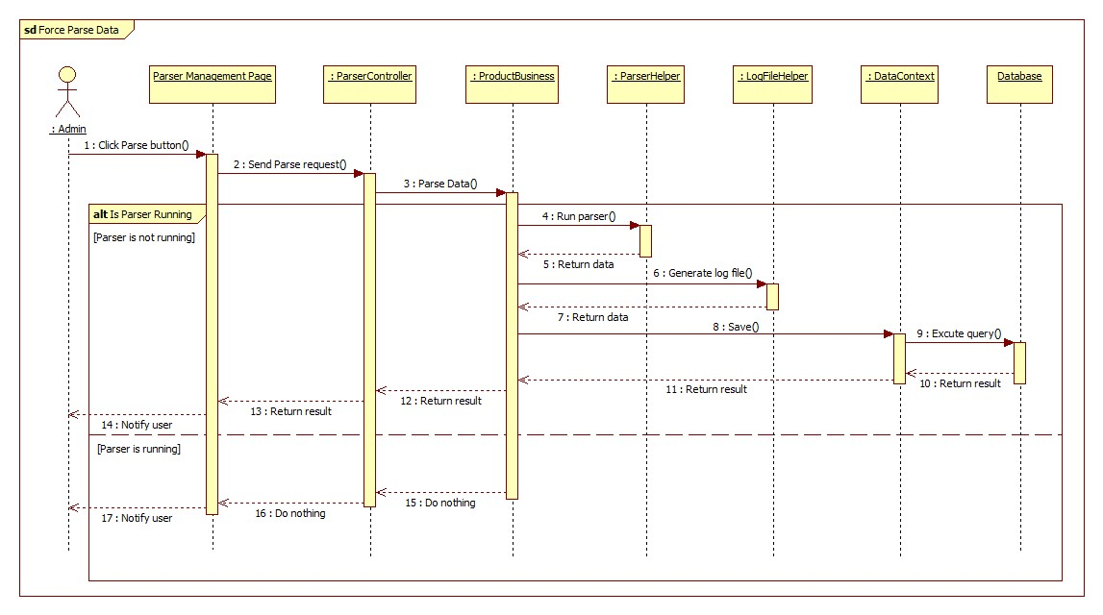

Figure 4: Force Parse Data Sequence Diagram

#### Import Excel

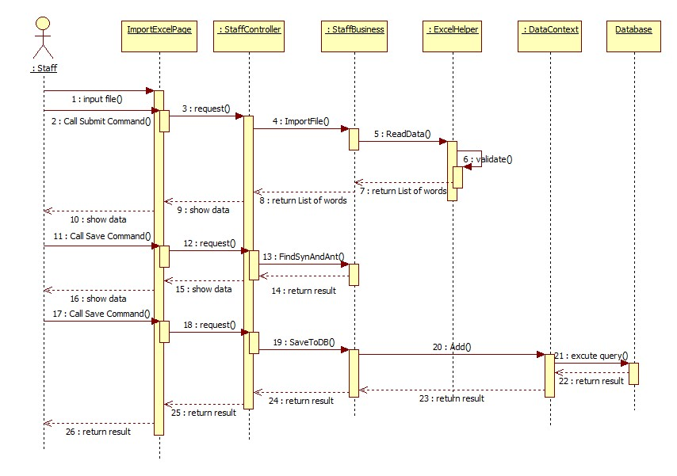

Figure 5: Import Excel Sequence Diagram

#### Search Laptop

#### Import Dictionary

#### Train Machine

## User Interface Design

## Database Design

### Logical Diagram

Figure 27: Logical Diagram

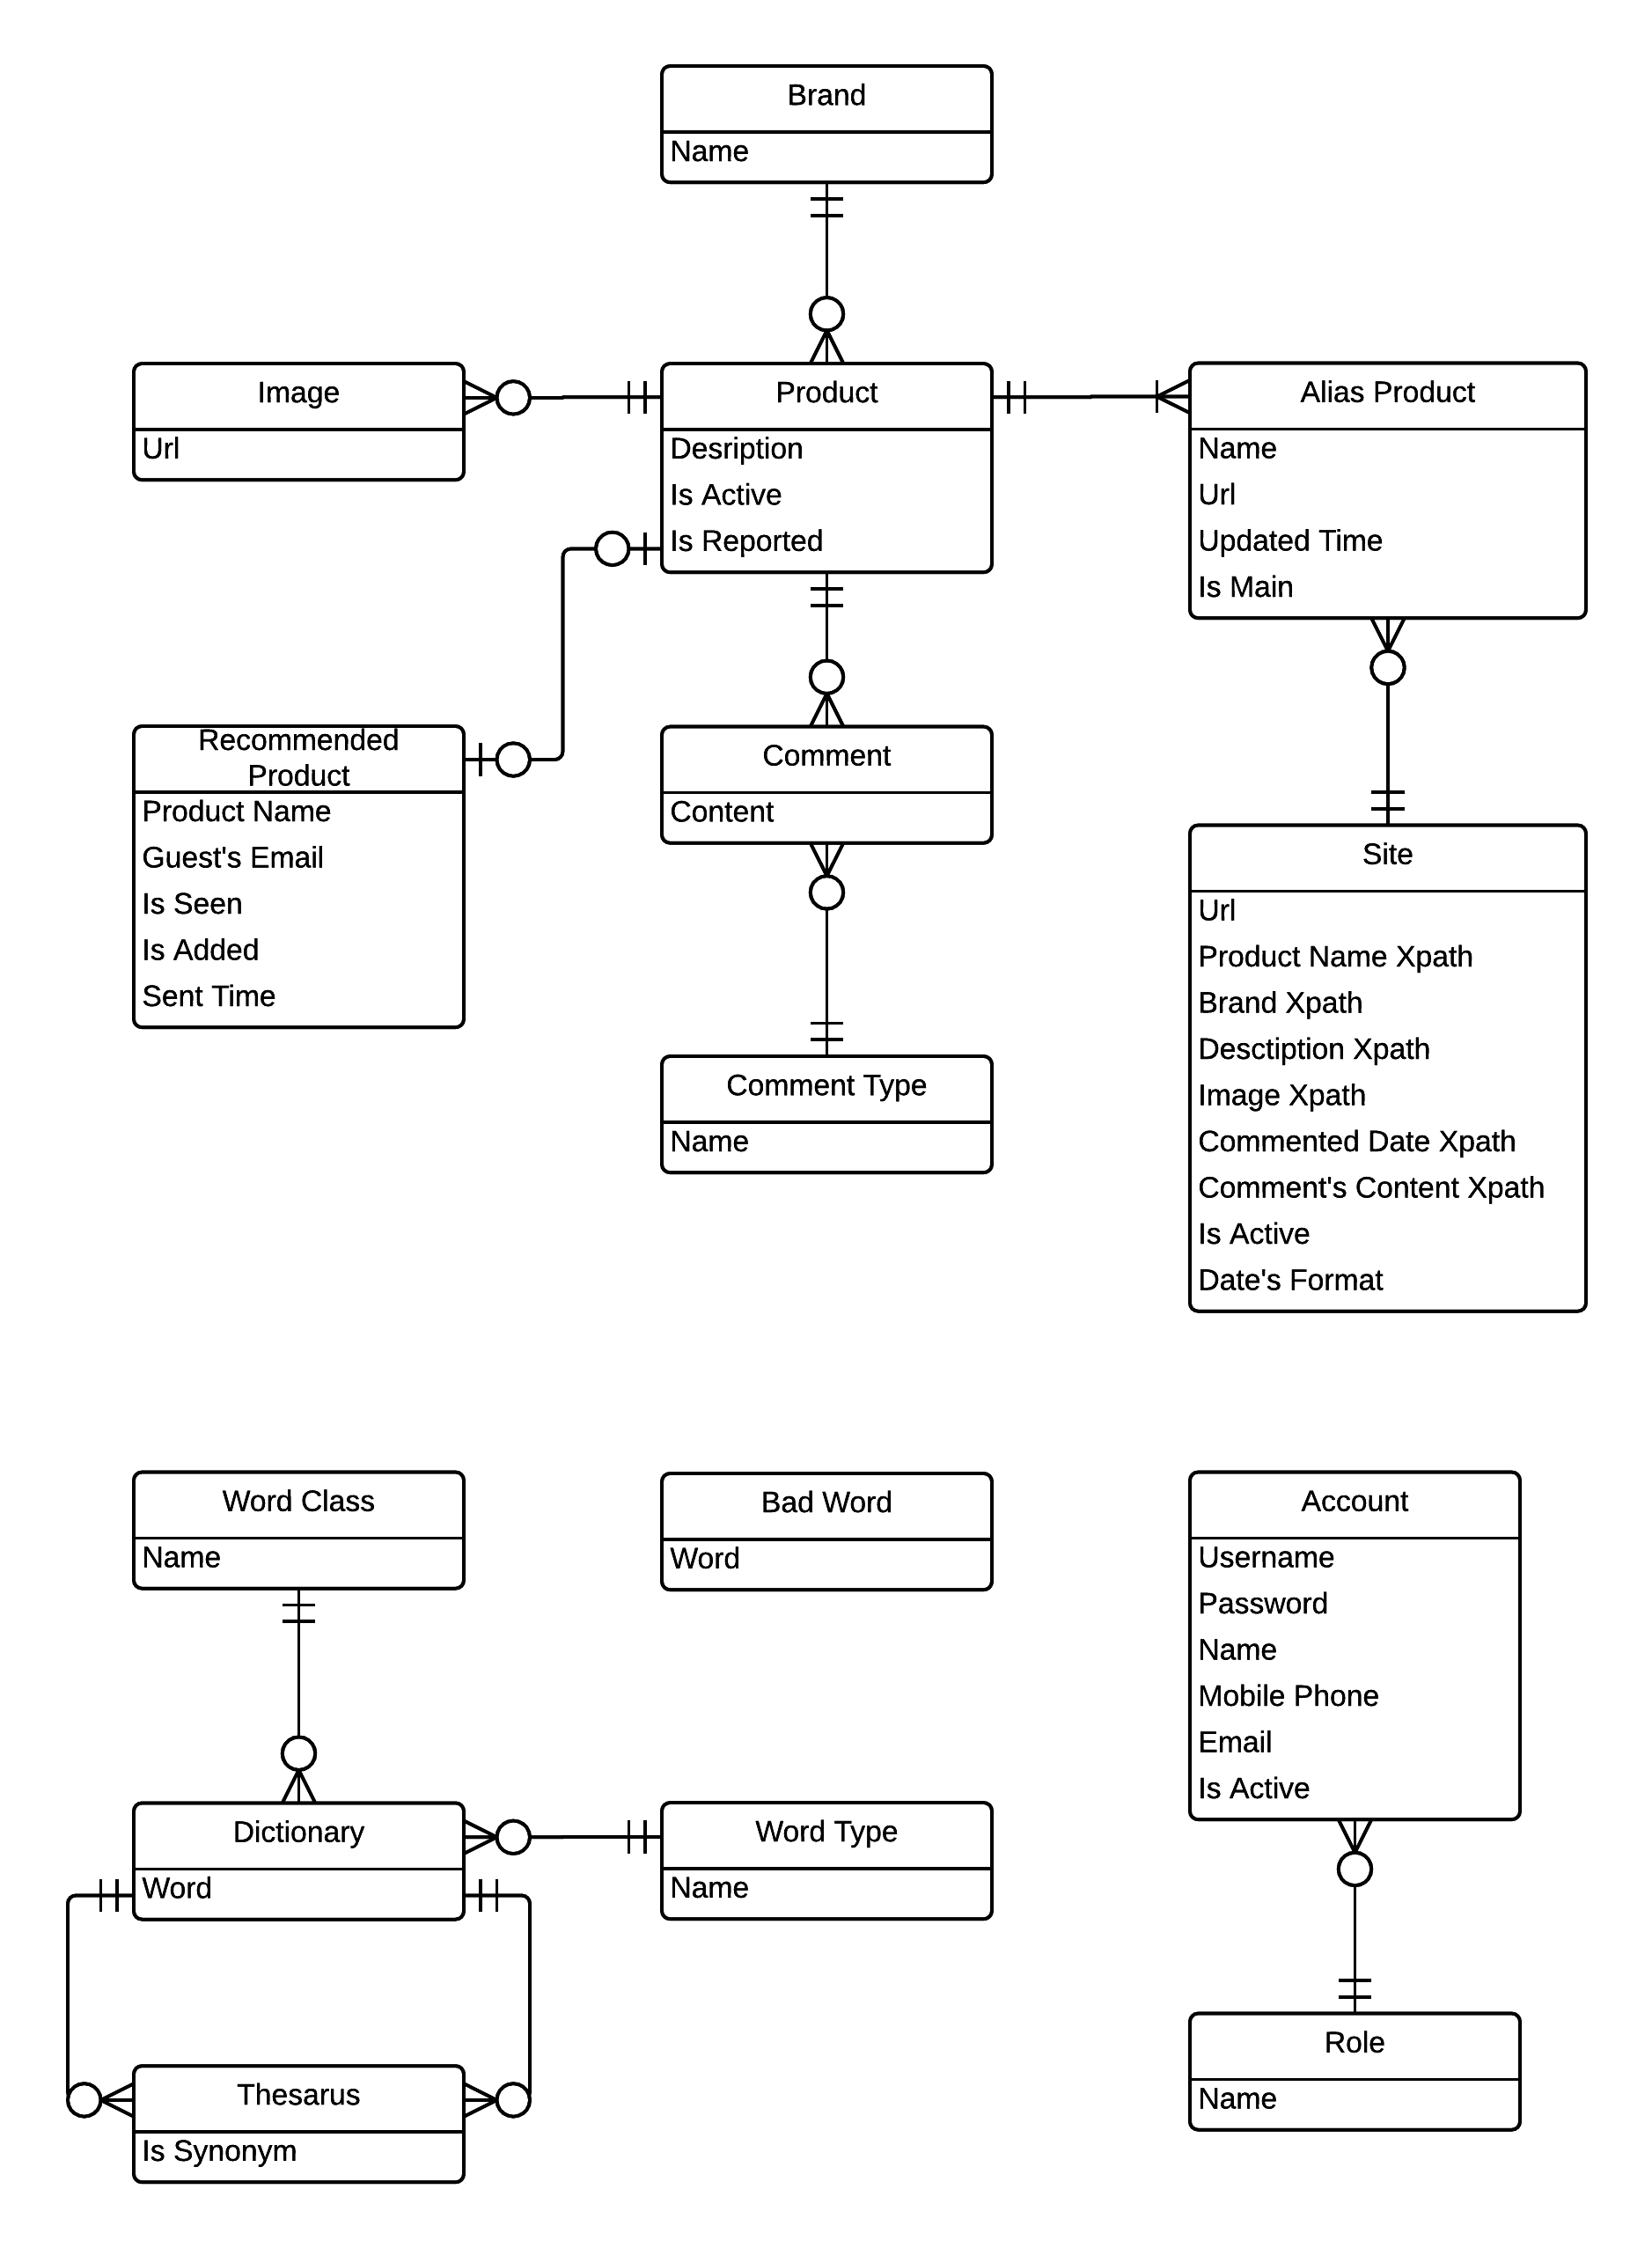

### Data Dictionary

|  |  |
| --- | --- |
| **Entity Data dictionary: describe content of all entities** | |
| **Entity Name** | **Description** |
| Image | Describe all image link that product is included. |
| Product | Describe all products in the system. |
| Alias Product | Describe all alias name of product in the system. |
| Brand | Describe all brand that product is included. |
| Comment | Describe all comment of products. |
| Comment Type | Describe all type of comments. |
| Site | Describe all site parse data. |
| Site Attribute | Describe all Xpath to parser attributes of site |
| Recommend Product | Describe all products that recommend by user. |
| Staff | Describe all information of staff. |
| Admin | Describe all information of admin. |

Table 1: Entity Data Dictionary

|  |  |  |  |  |
| --- | --- | --- | --- | --- |
| **Entity name** | **Attributes** | **Description** | **Domain** | **Nulls** |
|  |  |  |  |  |

Table 2: Attribute Data Dictionary

## Algorithms

### Analyze Comment

#### Define Problem

Given a sentence then the system will check whether that sentence has positive or negative or neutral meaning

#### Requirement (Should discuss: suggest: check grammar of sentence, length of sentence, can check some words no matter they’re spelled correctly or not)

#### Solution

* Manually prepare 10 lists of lower-cased words by reading first 100 comments:
* A list contains all words which meanings are totally Pros
* A list contains all adjectives and adverbs which meanings are Pros (these words’ positive meaning is not as strong as words in “Totally Pros” list)
* A list contains all adjectives and adverbs which meanings are Neutral
* A list contains all adjectives and adverbs which meanings are Cons
* A list contains all adjectives and adverbs which meanings are totally Cons (these words’ negative meaning is not as strong as words in “Totally Cons” list)
* A list contains all nouns and verbs which meanings are Pros (these words’ positive meaning is not as strong as words in “Totally Pros” list)
* A list contains all nouns and verbs which meanings are Neutral
* A list contains all nouns and verbs which meanings are Cons (these words’ negative meaning is not as strong as words in “Totally Cons” list)
* A list contains all nouns and verbs which meanings are totally Cons
* A list of negative words such as not, no, do not, does not …
* Lower case the whole sentence and break it into a list of words, then lower case all the words.
* With a list of words, we will check how many words of that list belong to the 10 lists above, then we divide into these cases:
* Case 1: List of words contains word(s) which belong to “Totally Pros” word list: In this case, the sentence will be Positive sentence.
* Case 2: List of words contains word(s) which belong to “Totally Pros” word list but it also contains word(s) which belong to “Negative” word list: In this case, the sentence will be Negative sentence.
* Case 3: We will check the adjectives and adverbs fist. So if list of words contains adjectives, adverbs and belongs to adjectives/adverbs’ “Pros”, “Cons” or “Neutral” lists, we will have these sub-cases:
* If there are more “Pros” words than “Cons” words 🡪 The sentence is positive (1)
* If there are more “Cons” words than “Pros” words 🡪 The sentence is negative (2)
* With those 2 above sub-cases, if there are words belong to “Negative” list, then the sentence will be negative with sub-case (1) and positive with sub-case (2)
* If the sentence contains no adjectives/adverbs that belongs to “Pros”, “Cons” and has words belong to “Neutral”, that sentence is neutral. If the sentence has same number of “Pros” and “Cons” adjectives/adverbs and has no “Neutral” adjectives/adverbs, we will check in Case 4.
* If there is no “Pros”, “Cons” and “Neutral” adjectives/adverbs in that sentence, we will check in Case 4.
* Case 4: After checking for adjectives, adverbs, we will check verbs and nouns in that sentence. We have these sub-cases
* If there are more “Pros” words than “Cons” words 🡪 The sentence is positive (1)
* If there are more “Cons” words than “Pros” words 🡪 The sentence is negative (2)
* With those 2 above sub-cases, if there are words belong to “Negative” list, then the sentence will be negative with sub-case (1) and positive with sub-case (2)
* If the sentence contains no verbs/nouns that belongs to “Pros”, “Cons” and has words belong to “Neutral”, that sentence is neutral. Similarly, if the numbers of verbs/nouns belongs to “Pros” and “Cons” are the same, that sentence is Neutral
* If there is no “Pros”, “Cons” and “Neutral” verbs in that sentence, it will be unidentified and will be decided later by staff

#### Example

Giving the sentence: “*This Mac is fast, and combined with Mavericks I am now getting some great battery life.”*

* Assume that we already have “Totally Pros” words list which contains “fast” and “great”
* Lower case the whole sentence:

+ This Mac is fast, and combined with Mavericks I am now getting some great battery life🡪 this mac is fast, and combined with mavericks i am now getting some great battery life

* Split sentence into list words:

+ this mac is fast, and combined with mavericks i am now getting some great battery life 🡪 {this, mac, is, fast, and, combined, with, mavericks, i, am, now, getting, some, great, battery, life}

* We will check for “Totally Pros” words first. In this case, we have 2 words: fast and great. These 2 words belongs to “Totally Pro” list, so this sentence is Positive.

### String Comparison

#### Define Problem

Given 2 strings. Calculate their matching percent.

#### Requirement

* A robustness to changes of word order: two strings which contain the same words, but in a different order, should be recognized as being similar.
* Language independence: the algorithm should work not only in English, but in many different languages.

#### Solution

* If a string contains many words, break it into a list of words.
* For each word, we find out how many adjacent character pairs are contained in it.
* Create a function *pairs(s)* which returns a list of adjacent character pairs of string *s*.
* Then, we use below formula to calculate matching percent.

#### Example

Calculate the matching percent of 2 strings: France and French.

* Upper case 2 strings:
  + MacBook Air 2015 MACBOOK AIR 2015.
  + MacBook Air 2015 Retina MACBOOK AIR 2015 RETINA
* Break string into list of adjacent character pairs:
  + MACBOOK AIR 2015
  + MACBOOK AIR 2015 RETINA
* Calculate its matching percent.